SUPERMARKET SALES REPORT
ASSIGNMENT-1

1.SALES DISTRIBUTION BY PRODUCT LINE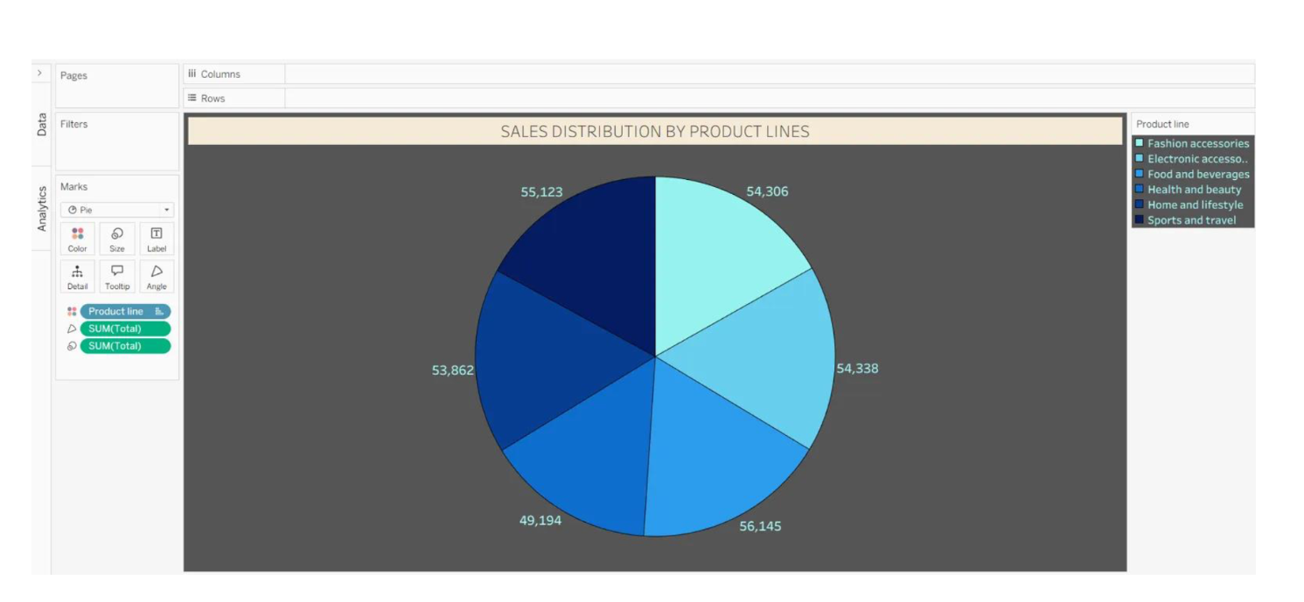

2.TOTAL SUM IN EACH CITY
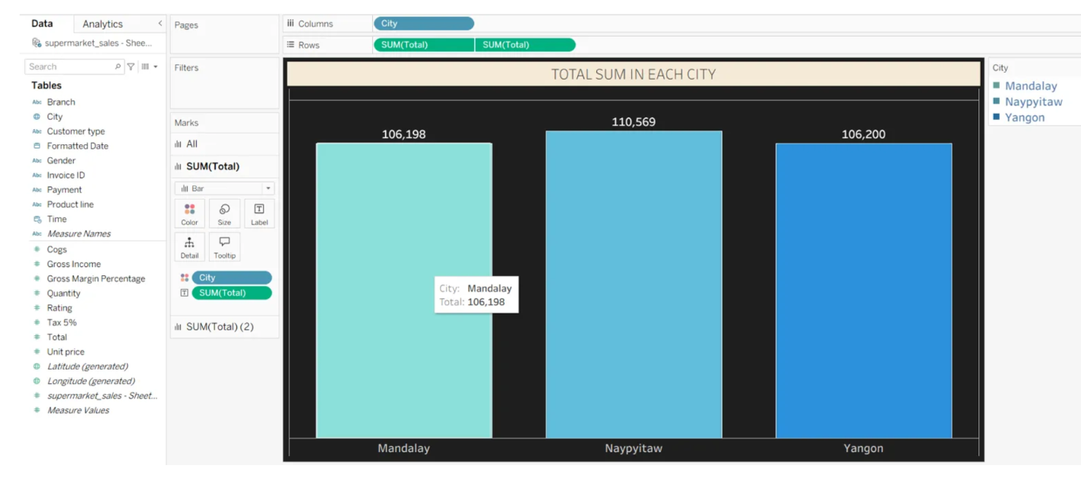

3.CUSTOMER TYPE BY PRODUCT LINES
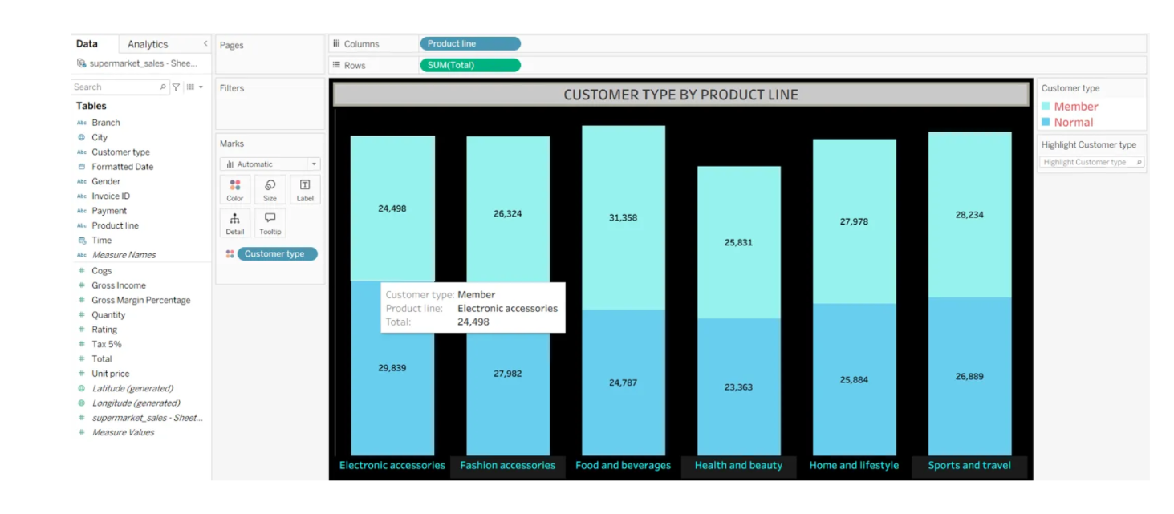

4.PAYMENT METHOD BY EACH MONTH
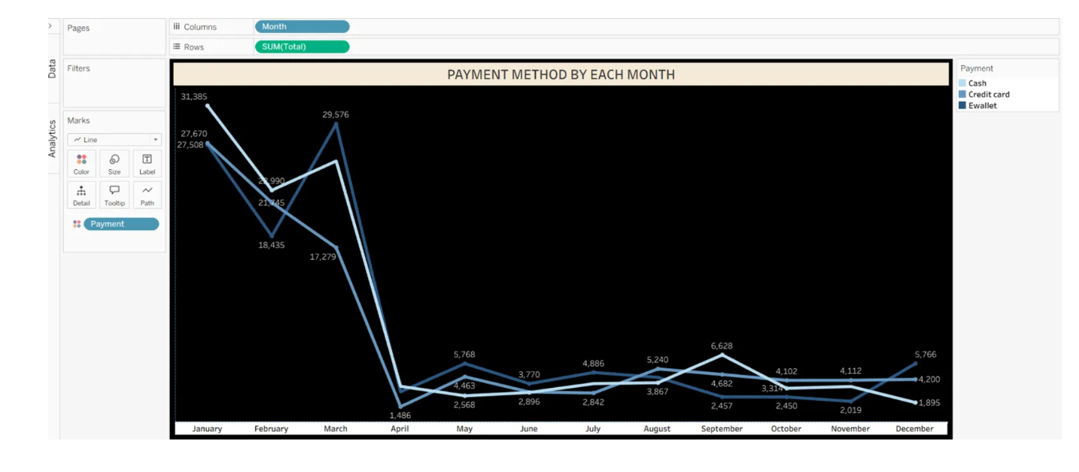

4.MONTH WISE SALES

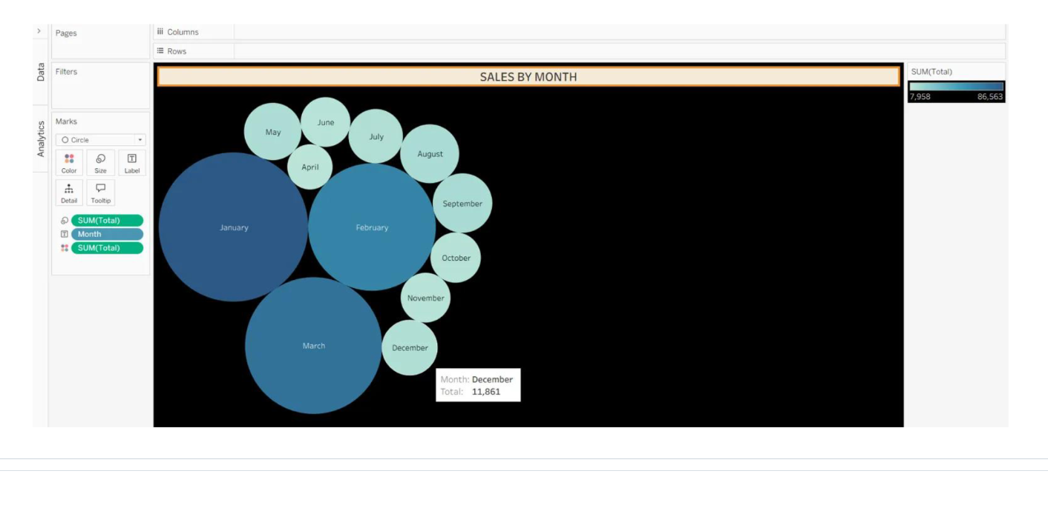

ASSIGNMENT-2

1.SALES BY PRODUCT LINE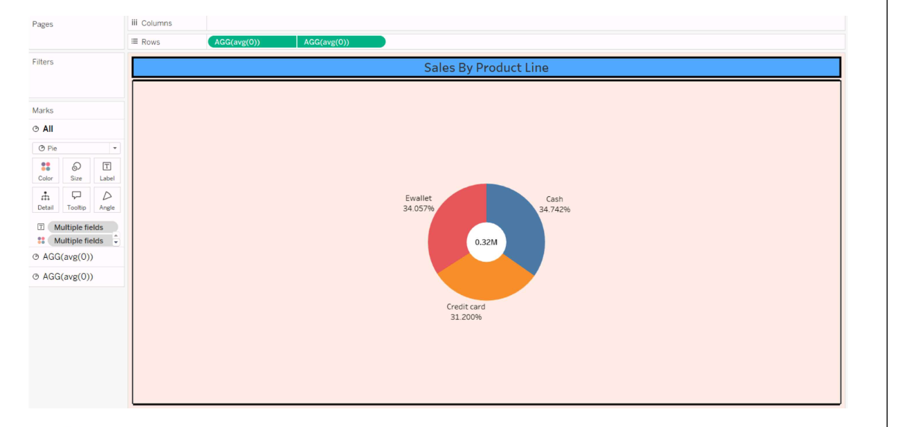

2.MONTH WISE TOTAL SALES
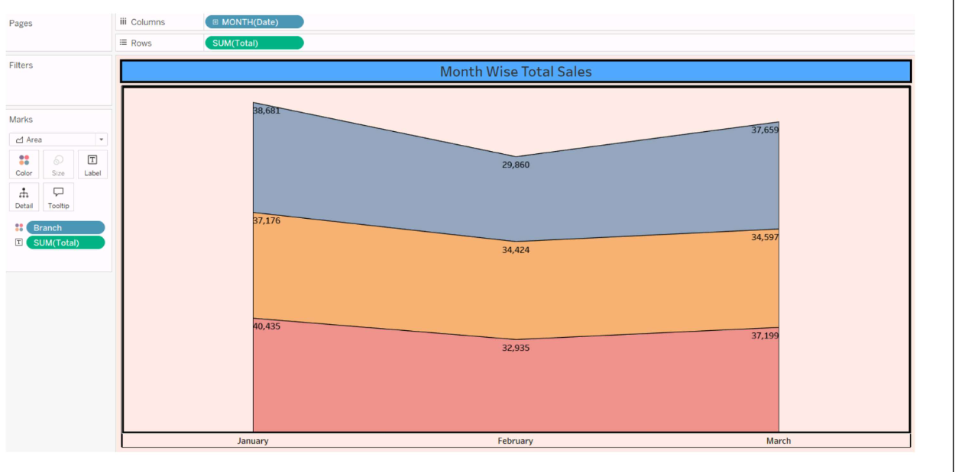

3.HIGHTLIGHT TABLE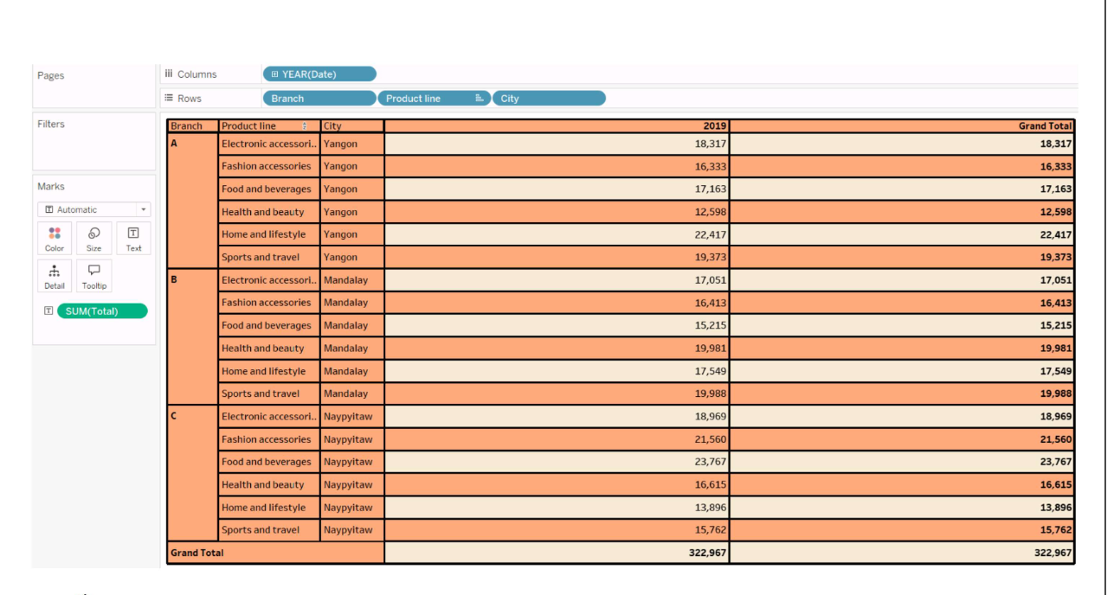

4.BRANCH WISE SALES BY PRODUCT LINE
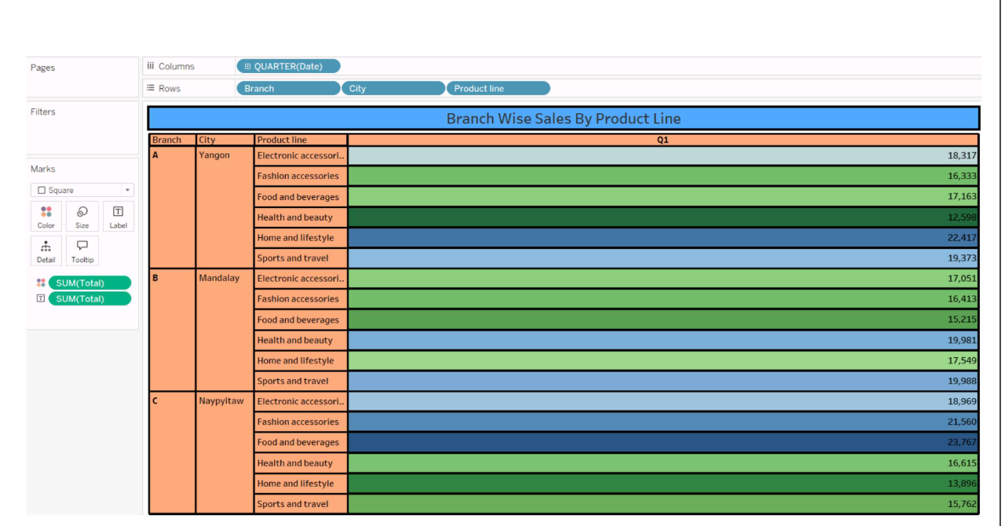

5.TOP PRODUCT LINE BY SALES
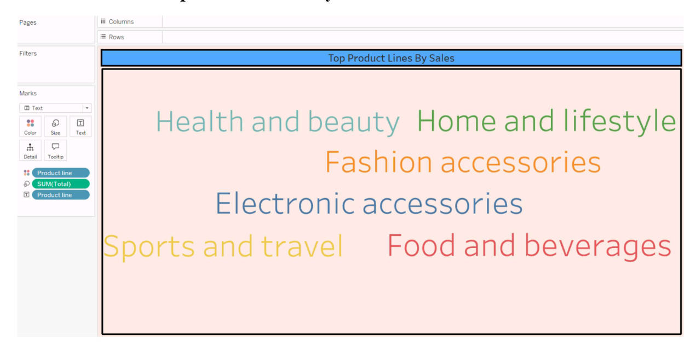

6.TOITAL SALES CONTRIBUTION BY PRODUCT LINE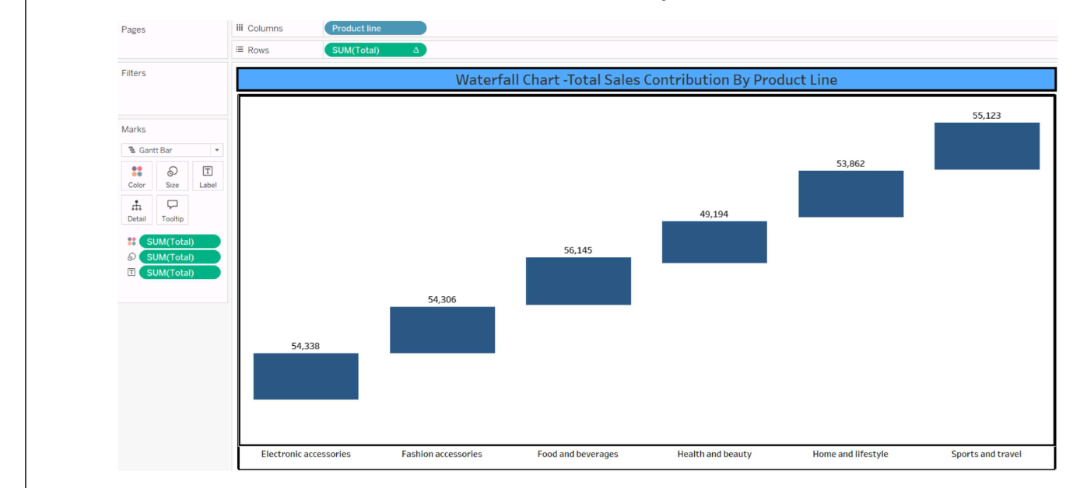

ASSIGNMENT-3

DASHBOARD-1:

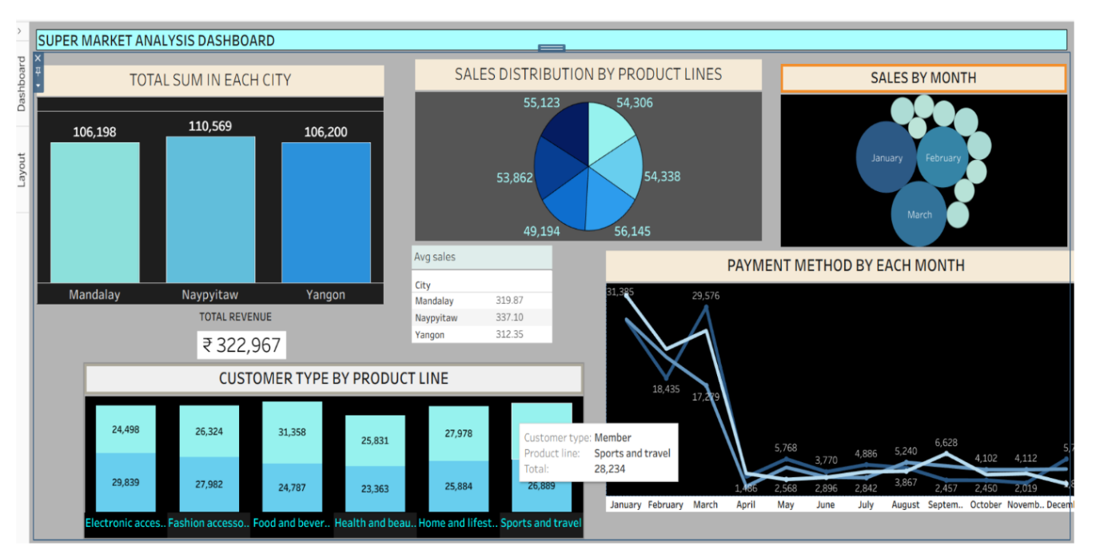

DASHBOARD-2:
